Who Am I?
Arkansas Entrepreneurs Activity

Prepare:
- Print the clue cards attached.
- Tape or pin a clue on the back of each person in the class. Each entrepreneur has five or six clues. You will need to adjust according to class size. You can leave out an entrepreneur or leave out a clue or two on some entrepreneurs. I recommend the former.
- Place a sticker or draw a like symbol on the back of each group of clues so that students can self-check after the grouping part of the activity.

Directions:
- This activity is to be completed without talking. Each student has a clue taped or pinned to his/her back.
- Other students read the clues. When a student recognizes that two clues go together, she should indicate with hand gestures that they should stay together.
- Students continue roaming the room reading clues and telling classmates when they should join a group.
- Continue until all students are placed in a group.
- Have each group take off their clues and check the symbol on the back to see that they have correctly grouped themselves. Regroup of needed.
- Have each group read the clues to each other.
- Have a spokesperson from each group to tell the class what they learned about their Arkansas entrepreneur.

Patricia P. Upton
Founded Aromatique based in
Heber Springs, AR
Combined love of fashion and art
and her knowledge of business to
create decorative fragrances.
Produces 11 lines of decorative room fragrances or scented mixtures of wood chips and botanicals found in nature.
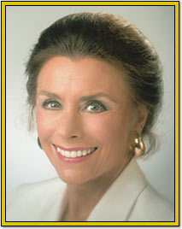
Samuel Moore Walton
Founded Walmart
Earned an undergraduate degree in economics from the University of Missouri.
Grew up during the depression. Knew that hard work and thrift were a way of life. Wanted to win.
Sold milk; waited tables in exchange for meals; was a lifeguard; delivered newspapers;
was a member of the school senate
and served in the military.
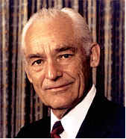
Sissy Jones
Founded Sissy’s Log Cabin
Jewelry Store
Originally in Pine Bluff
Hobnobs with guys from Cartier and Rolex in New York City with Southern belle savvy.
Grew up on a Delta farm.
Studied gemology and jewelry design.
Started selling antiques in a log cabin, migrated to jewelry and then created
the slide bracelet.
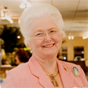
Ernest P. Joshua Sr. & Thelma Joshua
Founded J.M. Products, Inc. based in
Little Rock
Largest producer of ethnic hair care products
Began in mid-70s with store on West 14th Street in Little Rock
Joint ventures in Jamaica and South Africa
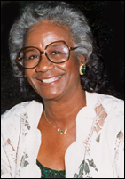
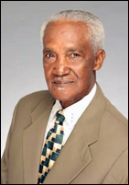
Forrest Wood
Father of the modern bass boat

Founded Ranger Boats in Flippin, AR in 1968
Manufactured Ranger Boats – designed by fishermen and built and tested
by fishermen for fishermen
Believes, “If you take care of your people and treat them right… and take care of your customers and treat them right… the company will continue to be successful.”
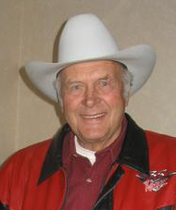
Lorena Larson
Founded Larson’s Language Academy to teach languages and provide interpretations and translations.
Started a business based on her interest in teaching and her language skills.
Sold property in Ecuador and borrowed money from family to start her business.


Charles H. Murphy, Jr.
Lead family business when he was 21 after his father’s death. Emancipated from his family at age 16 so he could operate as an independent in the oil industry.
Family owned timber land, oil wells,
and banks in Southern Arkansas.
Graduated from Eldorado High School.
Was a voracious reader.
Served as a director of
The Smithsonian Institute.
